 | Geometry Week 24 Name:
 | Monday | Tuesday | Wednesday | Thursday
- 6.G.1 | Find the area  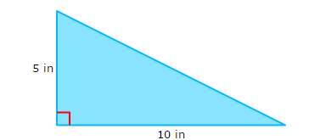 | Find the area  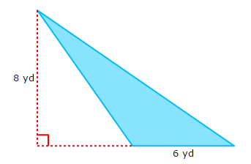 | Find the area  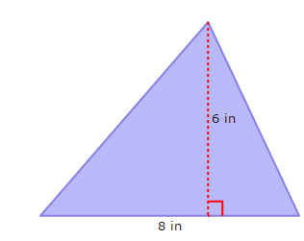 | What is the area of a square with a side of 5 cm.
- 6.G.1 | What is the missing base?  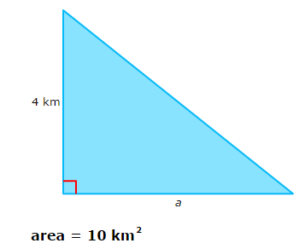 | Find the missing height  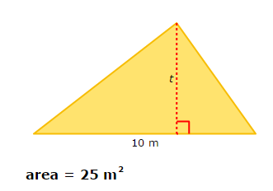 | Find the missing base  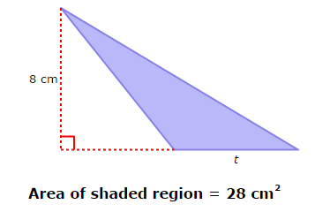 | Find the missing length  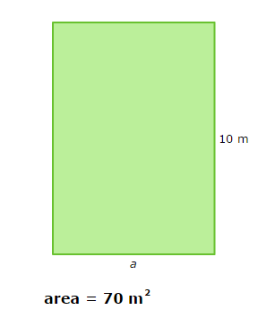
- 6.G.1 | Find the area of the parallelogram  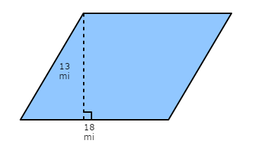 | Find the area of the parallelogram with a base of 10.2 ft and a height of 4.1 ft. | Find the area of the trapezoid  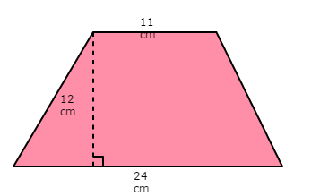 | Find the area of the trapezoid  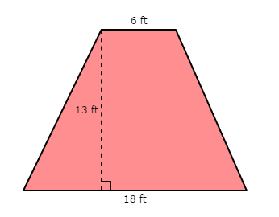
- 6.G.2 | Find the Volume  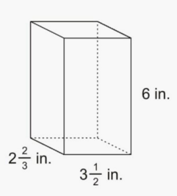 | Find the Volume  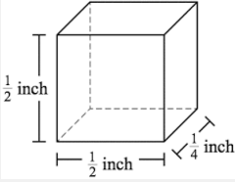 | Find the Volume  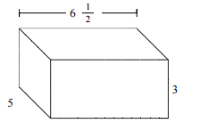 | Find the Volume  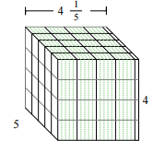
- 6.EE.9 | 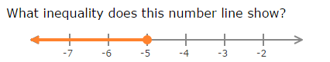 | Debbie has at most $60 to spend on clothes. She wants to buy 1 pair of jeans for $22 and some shirts that cost $8 each. Write the inequality and graph it on a number line. | Fill in the table using the equation  x 1 2 3 9  y  Equation: 72 ÷ x = y | Write the equation and fill in table  x 1 2 4 5  y 2 5 11  Equation:

