 | Geometry Week 25 Name:
 | Monday | Tuesday | Wednesday | Thursday
- 6.G.1 | Find the area of the triangle  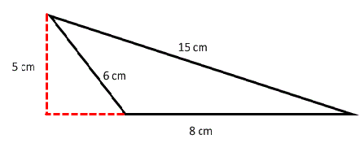 | Find the area of the parallelogram with  base 5.2 cm, height 7.1 cm. | Find the area of the trapezoid  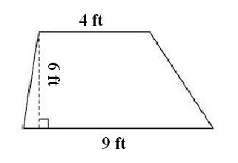 | Find the area of the trapezoid in cm.  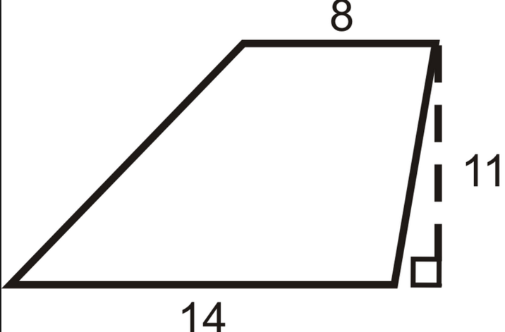
- 6.G.1/6.G.3 | Find the area in units with vertices  (1,10) , (9,10) , (8,2) , (0,2)  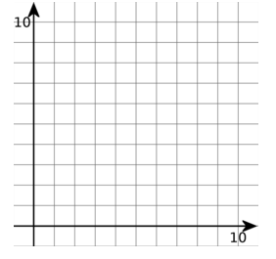 | Find the area of the triangle in units with vertices  (9,4) , (4,0) , (0,4)  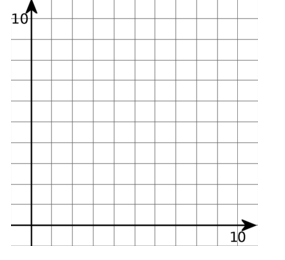 | Find the area of the trapezoid in units with vertices  (4,8) , (7,8) , (7,5) , (3,5)  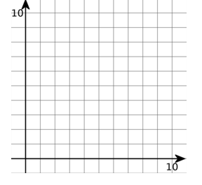 | Find the area of the trapezoid in units with vertices  (5,10) , (8,10) , (8,3) , (3,3)
- 6.G.1 | Find the area of the regular polygon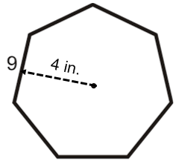 | Find the area of the regular polygon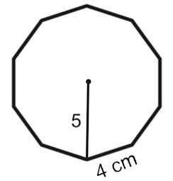 | Find the area of the regular polygon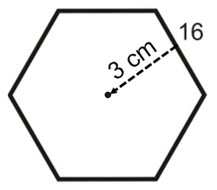 | Find the area of the regular polygon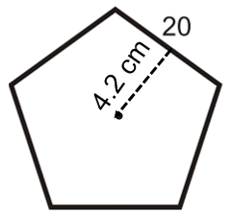
- 6.G.1 | Find the area of the shaded region  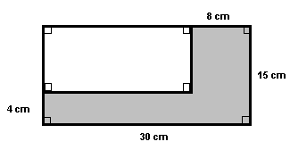 | Find the area of the Unshaded region  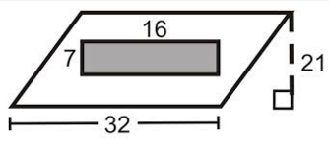 | Find the area of the shaded region  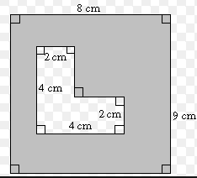 | Find the area of the shaded region  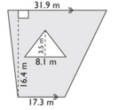
- 6.G.2 | Find the Volume in inches  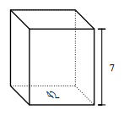 | Find the Volume in cm  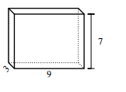 | Find the Volume in units  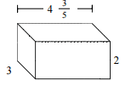 | Find the Volume with width 5.2 in. height 7.1 in. and depth 3.3 in.

