 | Geometry Week 26 Name:
 | Monday | Tuesday | Wednesday | Thursday
- 6.G.1 | Find the area of the triangle in ft. | Find the area of the parallelogram in inches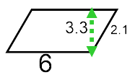 | Find the area of the trapezoid in cm | Find the area of the trapezoid  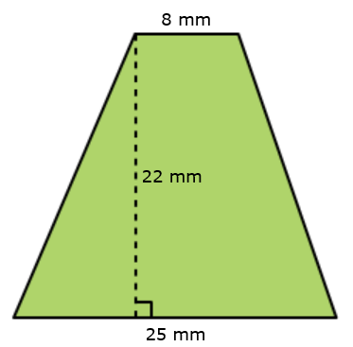
- 6.G.1/6.G.3 | Find the area in units with vertices  (2,10) , (10,10) , (8,2) , (0,2)  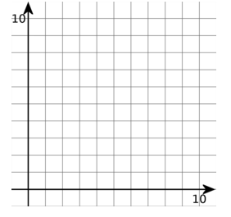 | Find the area of the triangle in units with vertices  (0,0) , (9,0) , (4,5)  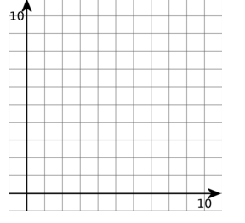 | Find the area of the trapezoid in units with vertices  (9,8) , (4,8) , (0,5) , (9,5)  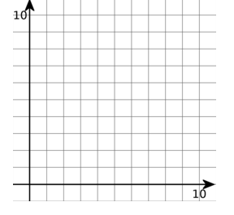 | Find the area of the trapezoid in units with vertices  (3,10) , (7,10) , (3,3) , (10,3)
- 6.G.1 | Find the area 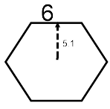 | Find the area 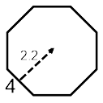 | Find the area 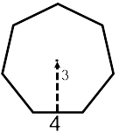 | Find the area of the regular polygon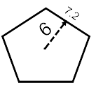
- 6.G.1 | Find the area of the shaded region  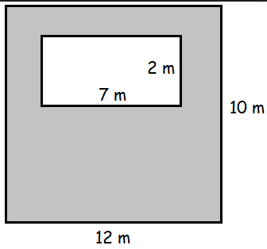 | Find the area  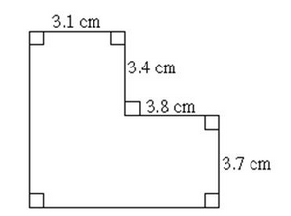 | Find the area of the shaded region  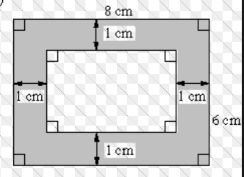 | Find the area  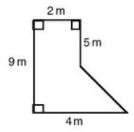
- 6.G.2 | Find the Volume with width 5 in. height 4.1 in. and depth 2.3 in. | Find the Volume in cm  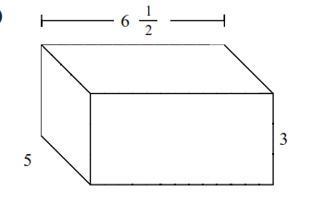 | Find the Volume  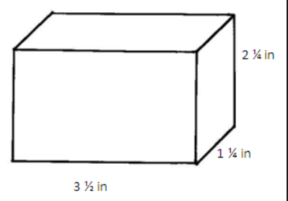 | Find the Volume  