 | Geometry Week 27 Name:
 | Monday | Tuesday | Wednesday | Thursday
- 6.G.1 | Find the area in feet  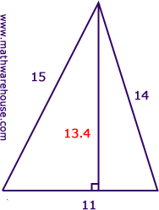 | Find the area of the in cm  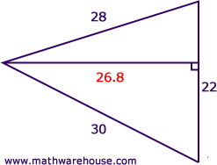 | Find the area of the trapezoid  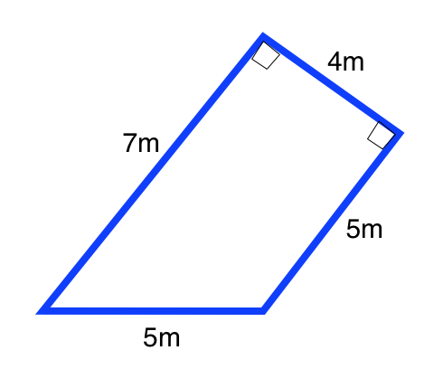 | Find the area of the trapezoid  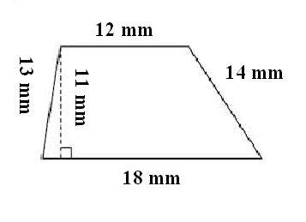
- 6.G.1/6.G.3 | Find the area in units with vertices  (0,0) , (2,8) , (8,0) , (10,8)  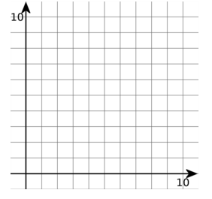 | Find the area of the triangle in units with vertices  (1,1) , (8,1) , (4,9)  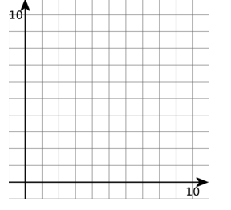 | Find the area of the trapezoid in units with vertices  (2,0) , (2,8) , (8,0) , (10,8)  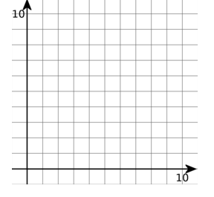 | Find the area of the parallelogram in units with vertices  (3,4) , (0,8) , (9,8) , (9,4)
- 6.G.1 | Find the area of the parallelogram  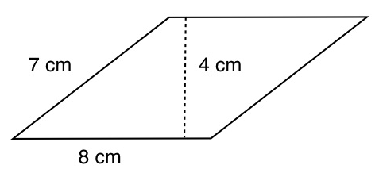 | Find the area parallelogram  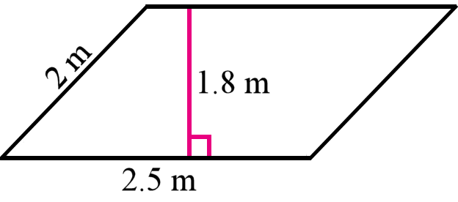 | Find the area of the hexagon | Find the area of the pentagon
- 6.G.1 | Find the area in inches  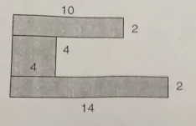 | Find the area of the shaded region  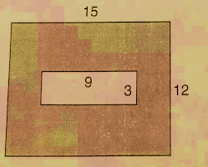 | Find the area of the shaded region  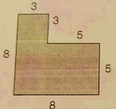 | Find the area  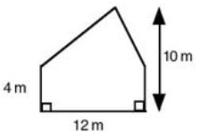
- 6.G.2 | Find the volume in inches  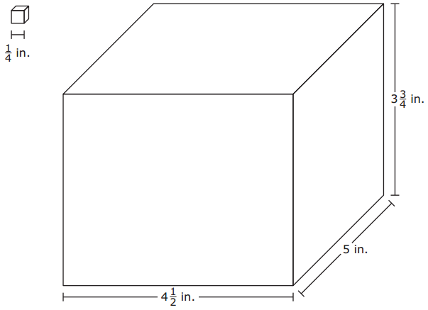 | Find the Volume in cm  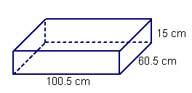 | A builder will be pouring concrete for a rectangular patio that is 12 feet wide, 14 feet long, and ½ foot thick. How many cubic feet of concrete will the builder need for the patio? | Find the volume of a rectangular prism that is 1 ½ cm by 1 ½ cm by 2 cm.

