 | Geometry Week 28 Name:
 | Monday | Tuesday | Wednesday | Thursday
- 6.G.1 | Find the area  9 in  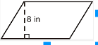 | Find the area of the triangle  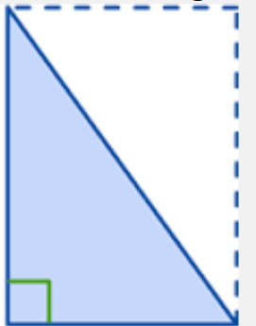  7 cm  6 cm | Find the area of the parallelogram  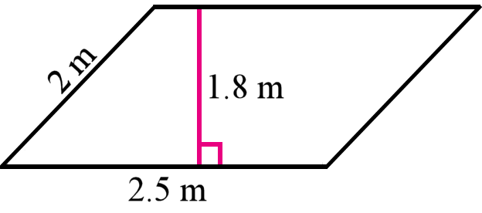 | Find the area of the trapezoid  4 ft  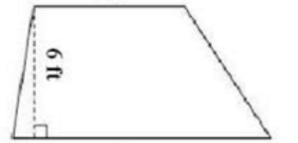  9 ft
- 6.G.1 | Find the area  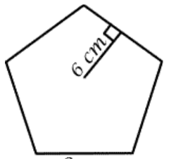  9 cm | Find the area of the hexagon | Find the area  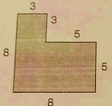 | Find the area  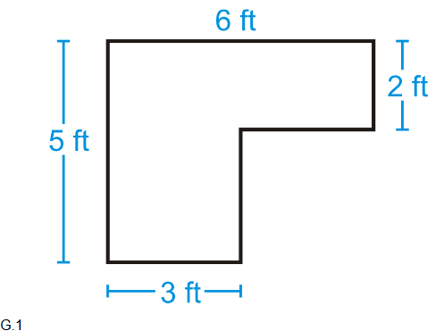
- 6.G.2/4 | 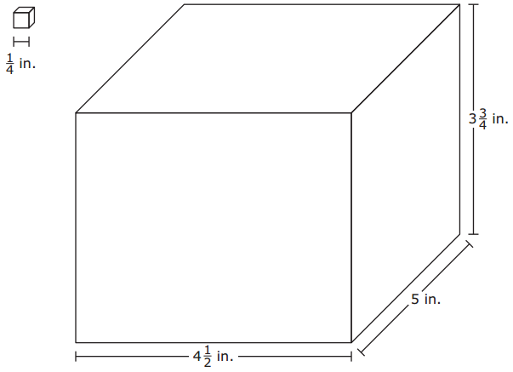  Find the volume  2 ½  6 in | Find the volume of a rectangular prism that is 1 cm by 1 ½ cm by 2 cm. | Plot and connect the points A(3, 2), B(3, 7), and C(8, 2).  What is the length of AB?  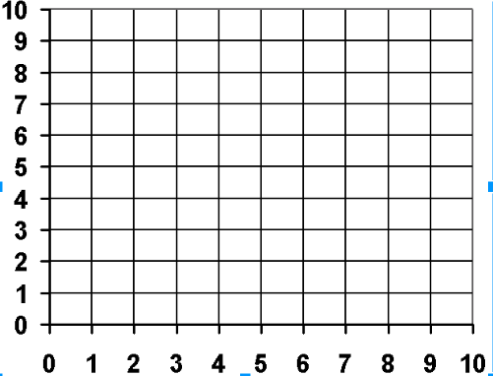 | Plot and connect the points  A(4, 5), B(6, 7), and C(4, 7).  What is the length of BC?
- 6.G.4 | Draw the net for this solid. What is the name? | What is the surface area for this rectangular prism  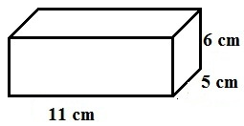 | Find the surface area  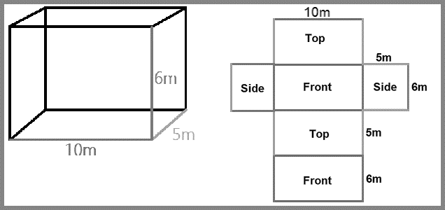 | Find the surface area of this shape using a net. What is this shape?  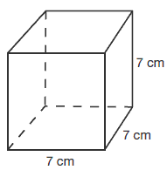
- 6.G.1/4 | What solid is this?  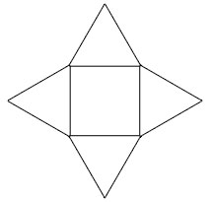 | Find the surface area of this solid.  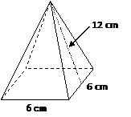 | Mary wants to cover a shoe box with exactly the right amount of fabric. The show box is 5 cm by 6 cm by 3 cm. How much fabric would she need to cover the box? | Tom wants to increase the triangle’s area by multiplying the base AND the height by 7. How will the new area be affected?  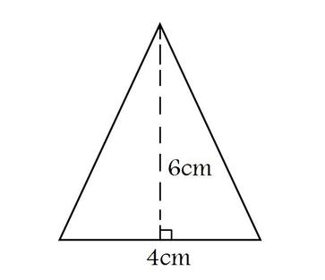  Old area:______  New area: _______  New area affected: ________

