Name: Room: Date:
Geometry
Week 22
 | TUESDAY | WEDNESDAY | THURSDAY
6.EE.8  7NS.2a | 1.  Express X > -140 using a number line below. | 1.  Express X > -160 using a number line below. | 1.  Express X > 10 using a number line below.
7.G.4 | 2.  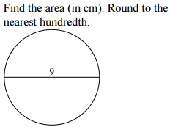 | 2.  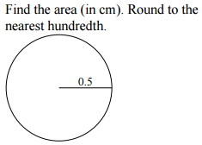 | 2.  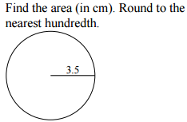
6.G.2 | 3.  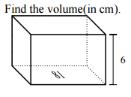 | 3.  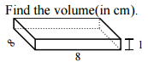 | 3. 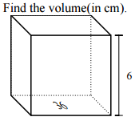
7.EE.1 | 4.  -2(-9-8+7v) | 4.  -5(9-10v) | 4.  -7(5+5)+2v
6.G.1 | 5.  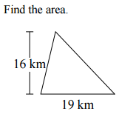 | 5.  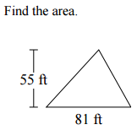 | 5.  