 | Expressions and Equations / Geometry Week 23 Name:
 | Monday | Tuesday | Wednesday | Thursday
- 6.EE.1 | Evaluate:  16÷2×8+3² | Evaluate:  (5+3)² | Evaluate: | Evaluate:  8+(2×5)×3⁴÷9
- 6.EE.9 | Maria saves $0.75 out of her allowance each week. She used the equation y=0.75x to determine how much money she saved last month. What does the x represent in the equation? | At the basketball game, the Tigers scored twice as many points as the Sharks. Write an equation that describes the relationship between x, the number of points scored by the Tigers, and y, the number of points scored by the Sharks? | Which statement BEST describes the relationship between x and y in the graph? 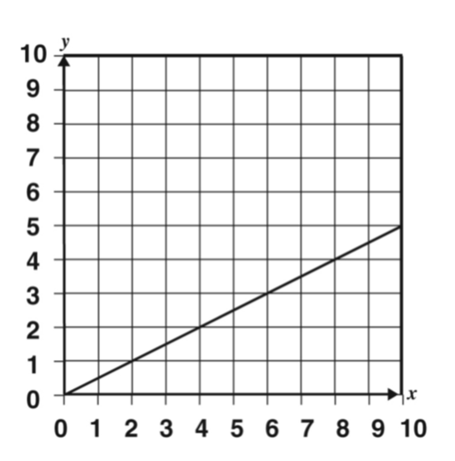  a) y is twice x  b) y is one half of x  c) y is two less than x  d) y is two more than x | Mrs. Garza is buying boxes of crayons for her classroom. The table below shows the number of crayons she can buy.  Boxes (B) of Crayons Number (N) of Crayons  1 16  2 32  3 48  Write an equation that will help Mrs. Garza determine the number of crayons she will get with B boxes?
- 6.G.1 | Find the area. Each unit is 1 cm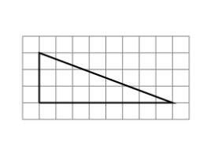 | The figure below is divided into four small squares. The sides of each small square are 6 cm long. What is the area, in square centimeters, of the entire figure?  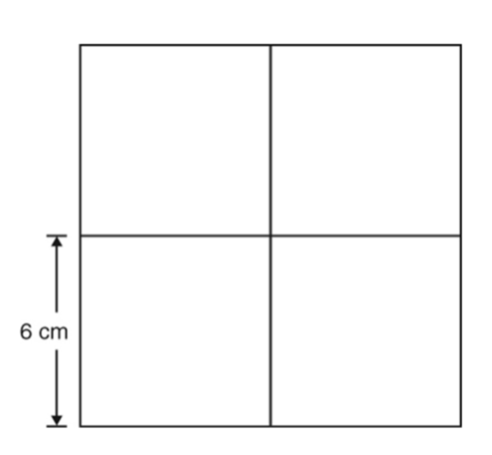 | Find the area. Each unit is 1 ft.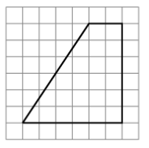 | Find the area. 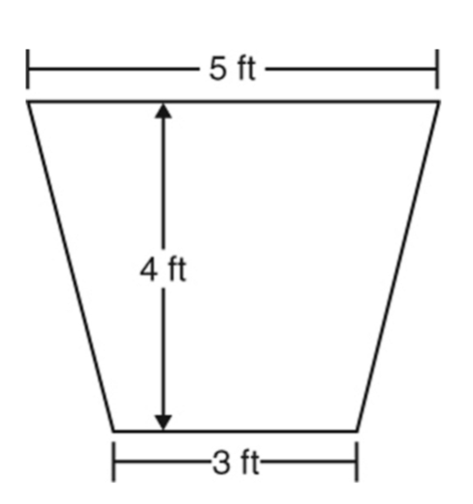
- 6.G.1 | Cheryl marked off two triangular areas for her lambs. The two areas formed a parallelogram. The base of each triangle was 20 feet and the height of each was 6 feet. What is the area of the parallelogram formed? | Ty drew a parallelogram using two triangles that each had a base of 11 centimeters and a height of 8 centimeters. What is the area of the parallelogram Ty drew? | Find the area | Find the height.
- 6.G.1 | Find the area and the perimeter | Find the height. | Find the area. | Find the area.

